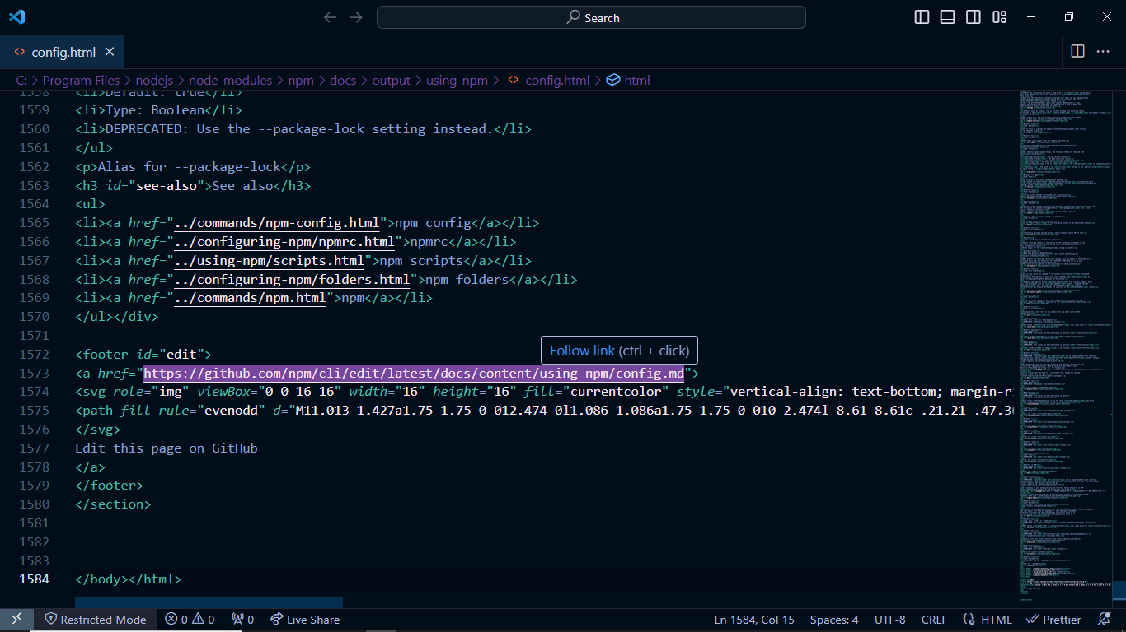

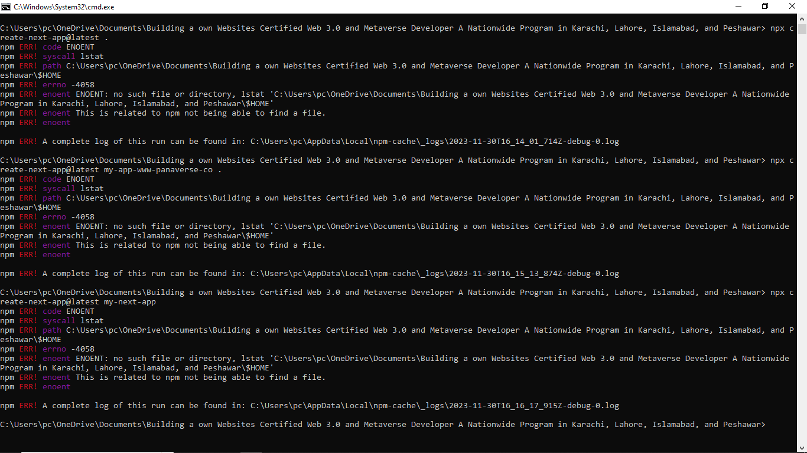

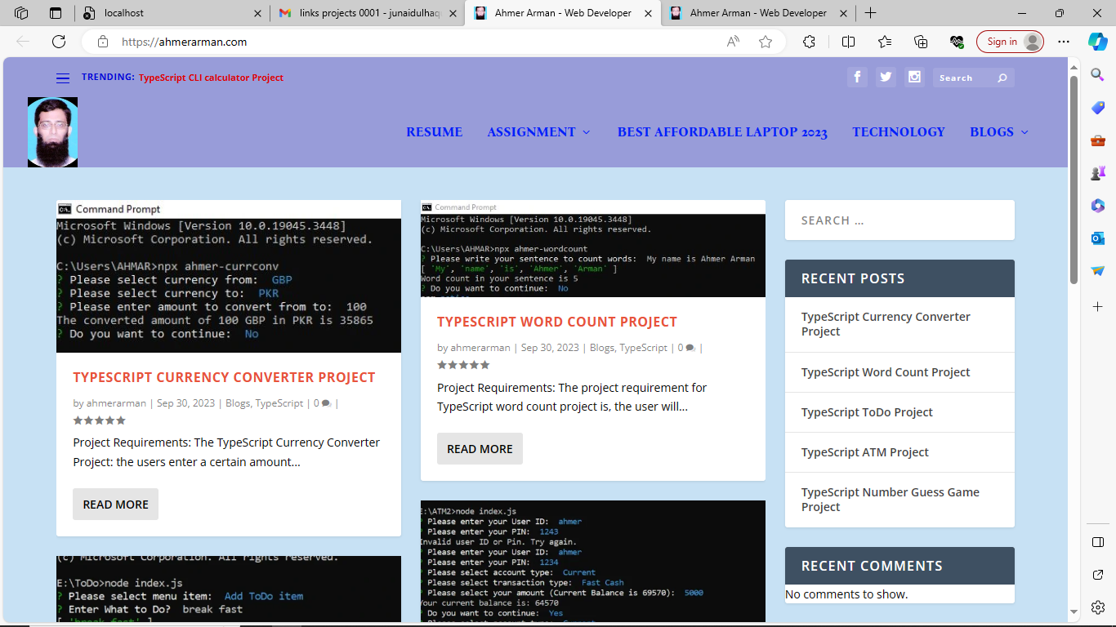

Ahmer Arman - Web DeveloperAhmer Arman - Web DeveloperAhmer Arman - Web DeveloperAhmer Arman - Web DeveloperAhmer Arman - Web DeveloperAhmer Arman - Web DeveloperAhmer Arman - Web DeveloperAhmer Arman - Web DeveloperAhmer Arman - Web DeveloperAhmer Arman - Web DeveloperAhmer Arman - Web DeveloperAhmer Arman - Web DeveloperAhmer Arman - Web DeveloperAhmer Arman - Web DeveloperAhmer Arman - Web DeveloperAhmer Arman - Web DeveloperAhmer Arman - Web DeveloperAhmer Arman - Web Developer

npx create-next-app@latest my-first-responsive-portfolio-projects-madebyjunaidulhaquesheikh-0001 .

- Haque1304$$$@@@
- ==========================================================================================================================

https://fontawesome.com/search?q=heart&o=r&m=free
https://fontawesome.com/search?q=heart&o=r&m=free
https://fontawesome.com/search?q=heart&o=r&m=free

Error: Cannot find module 'C:\Users\pc\OneDrive\Desktop\my-portfoilo\my-app\server.js'
at Module._resolveFilename (node:internal/modules/cjs/loader:1144:15)
at Module._load (node:internal/modules/cjs/loader:985:27)
at Function.executeUserEntryPoint [as runMain] (node:internal/modules/run_main:135:12)
at node:internal/main/run_main_module:28:49 {
code: 'MODULE_NOT_FOUND',
requireStack: []
}

Node.js v20.10.0
Error: Cannot find module 'C:\Users\pc\OneDrive\Desktop\my-portfoilo\my-app\server.js'
at Module._resolveFilename (node:internal/modules/cjs/loader:1144:15)
at Module._load (node:internal/modules/cjs/loader:985:27)
at Function.executeUserEntryPoint [as runMain] (node:internal/modules/run_main:135:12)
at node:internal/main/run_main_module:28:49 {
code: 'MODULE_NOT_FOUND',
requireStack: []
}

Node.js v20.10.0
Error: Cannot find module 'C:\Users\pc\OneDrive\Desktop\my-portfoilo\my-app\server.js'
at Module._resolveFilename (node:internal/modules/cjs/loader:1144:15)
at Module._load (node:internal/modules/cjs/loader:985:27)
at Function.executeUserEntryPoint [as runMain] (node:internal/modules/run_main:135:12)
at node:internal/main/run_main_module:28:49 {
code: 'MODULE_NOT_FOUND',
requireStack: []
}

Node.js v20.10.0
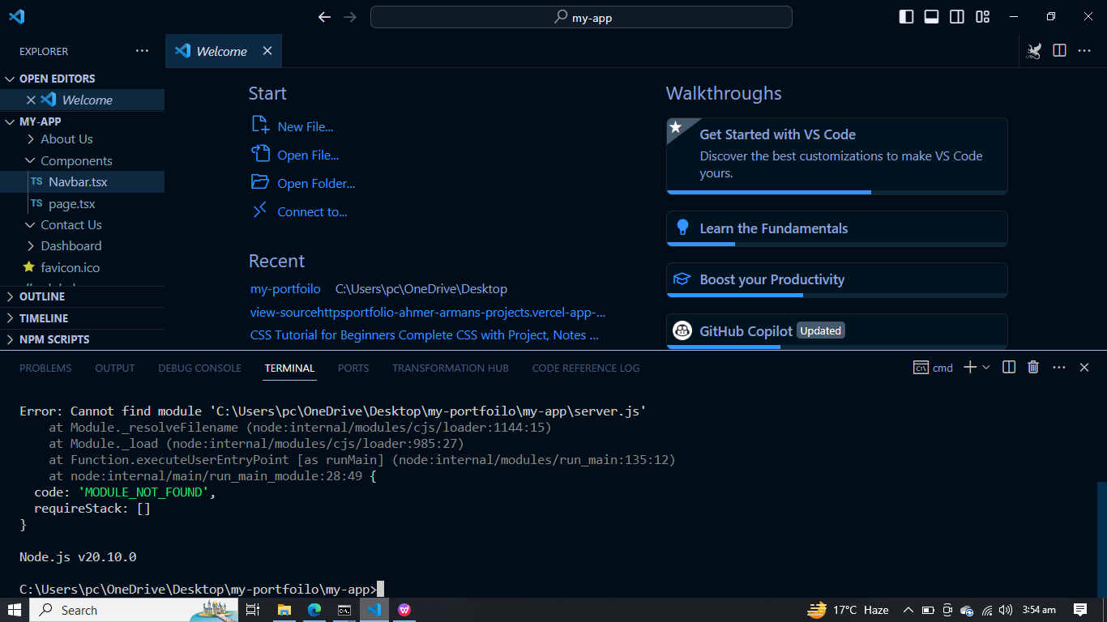

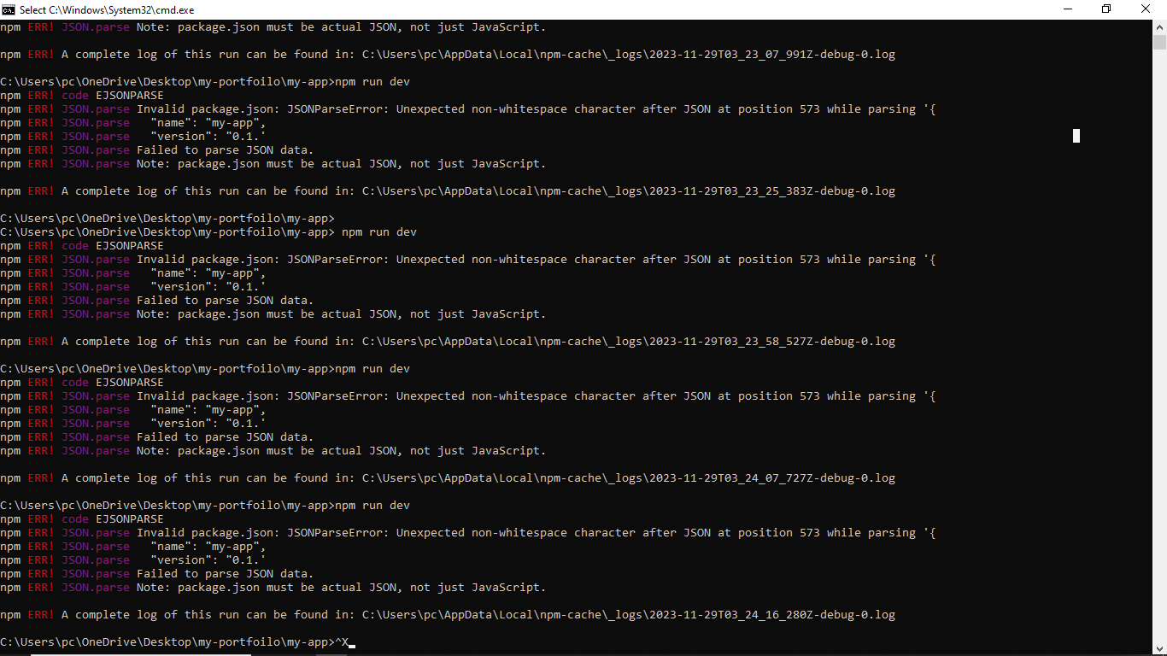
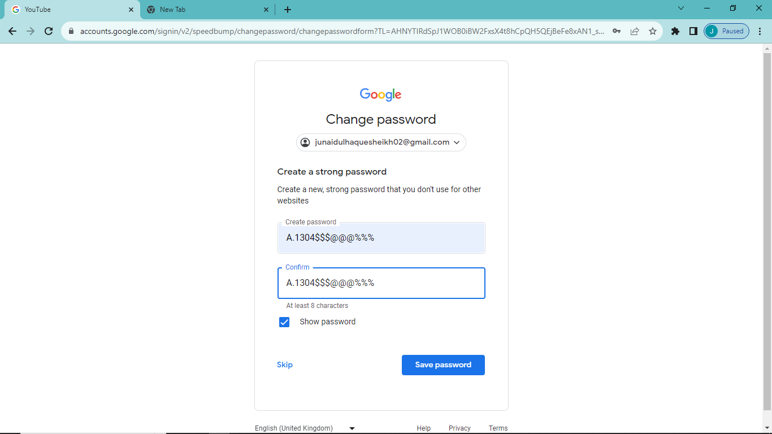
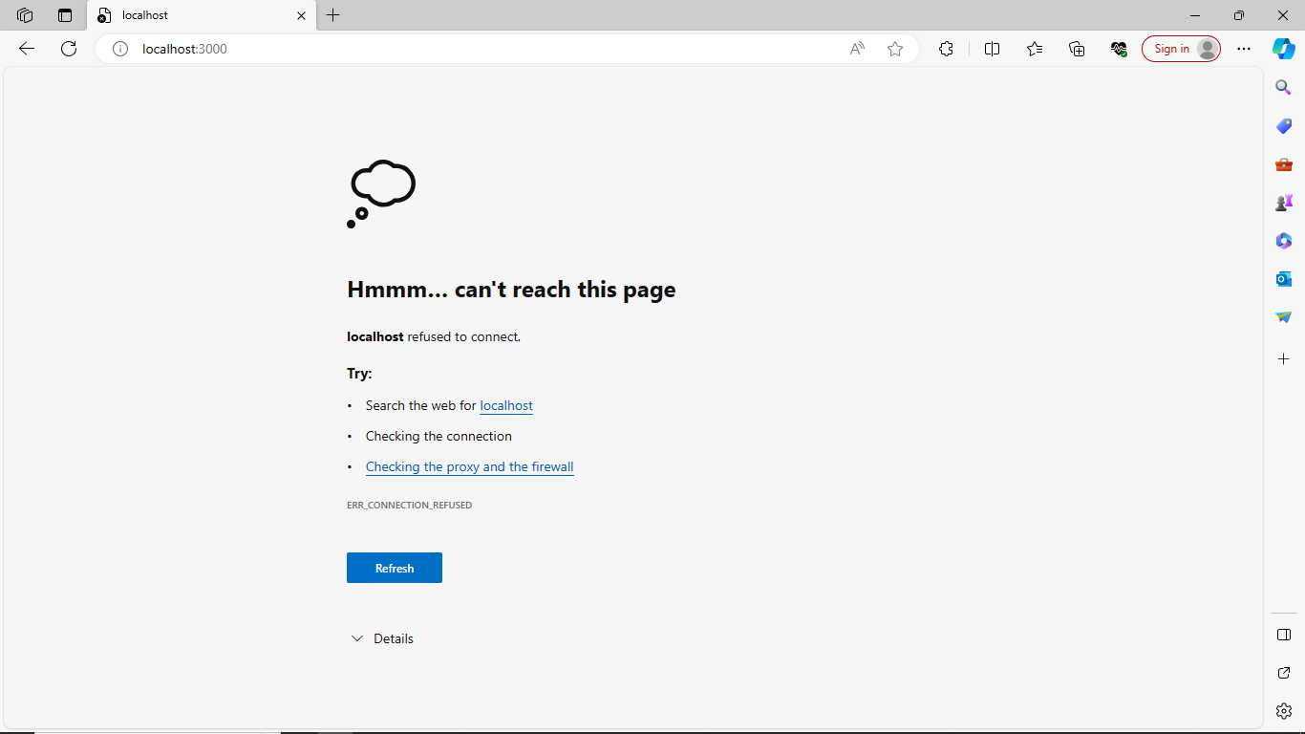
Ahmer Arman - Web Developer
Ahmer Arman - Web Developer
Ahmer Arman - Web Developer
Ahmer Arman - Web Developer
Ahmer Arman - Web Developer
Ahmer Arman - Web DeveloperAhmer Arman - Web DeveloperAhmer Arman - Web DeveloperAhmer Arman - Web DeveloperAhmer Arman - Web DeveloperAhmer Arman - Web DeveloperAhmer Arman - Web DeveloperAhmer Arman - Web DeveloperAhmer Arman - Web DeveloperAhmer Arman - Web DeveloperAhmer Arman - Web DeveloperAhmer Arman - Web DeveloperAhmer Arman - Web DeveloperAhmer Arman - Web DeveloperAhmer Arman - Web DeveloperAhmer Arman - Web DeveloperAhmer Arman - Web DeveloperAhmer Arman - Web DeveloperAhmer Arman - Web DeveloperAhmer Arman - Web DeveloperAhmer Arman - Web DeveloperAhmer Arman - Web DeveloperAhmer Arman - Web DeveloperAhmer Arman - Web DeveloperAhmer Arman - Web DeveloperAhmer Arman - Web Developer

